CLUTCH
Sounds very much like the clutch plates are worn out. A new set of plates is about £40, + £8 gasket + £3 clutch nut. Any garage should turn the job round in an hour. It's a fairly easy to do yourself although will require a special tool. If your doing it yourself then the tool can be got from forum member Gazzah for about £15. You'll also need the basic allen-keys and socket set.
You'll want to check that the 3 diaphram springs and the clutch plates are within their service limit before having them replaced though, just in case it isn't the cause of the problem. If the 3 clutch springs need doing you'll need to budget another £35ish though. I'm not sure if you may be able to just add another spring in as apposed to replacing the set of three, which would only be £13ish.

RS250 SHOCK
prilia RS250 SACHS SHOCK MOD
-Mainly taken from bits on this site and correspondence with the 400 forum members - thanks guys.
* Please let me know if I missed something and will edit this! *
WHICH SHOCK?
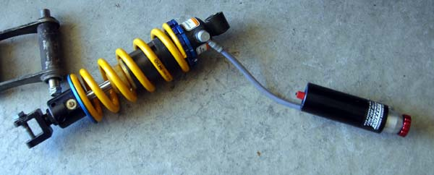
Try to get one with an adjustable ride height. Find one no later than 1998-99. Not sure myself, since I picked one up from an RS250 Cup bike. From what I've been told, all the Cup bikes came with adjustable ride height.
Here's the earlier model RS250 shock. This one does not have a ride height adjuster and according to RichNZ is better made and easier to rebuild than the later model.
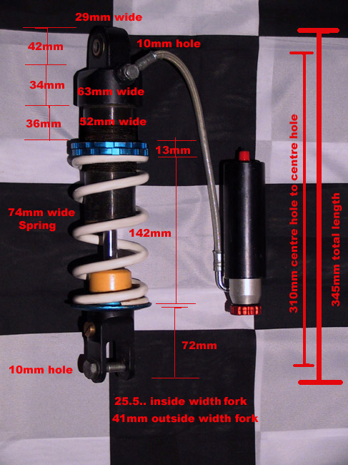
FITTING?
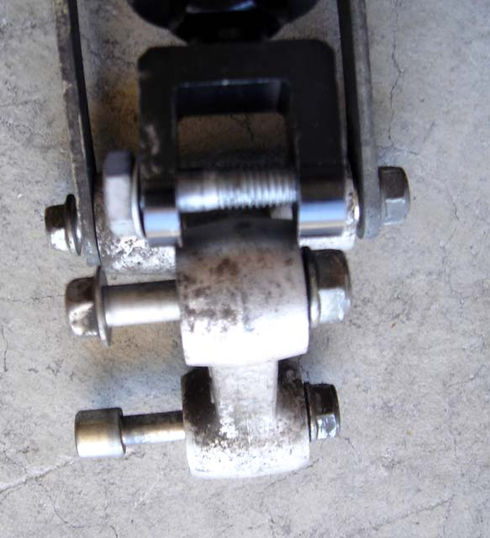
Grind 1.5mm on each side of the NC30's triangle linkage where the bottom of the shock mounts since the RS's mounting linkage is narrower than the NC30s. If you have the earlier model RS shock, the top of shock needs to be shaved a bit to clear the frame.
This is what it will look like after you mod the linkage.
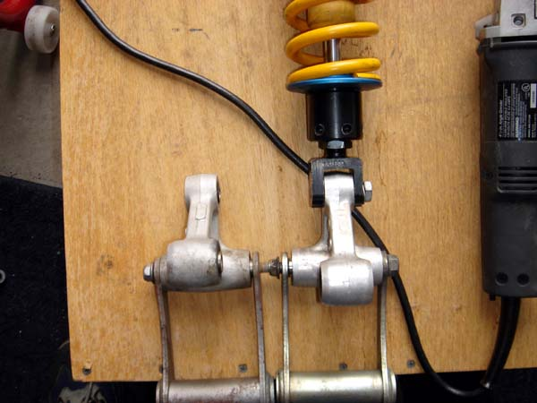
SPRING?
A stock RS250 spring is 325lbs. A stock NC30 is little more than double the RS spring; hence, you will need to ditch the RS’s spring. You can easily get the spring off the RS shock, but you'll need spring compressors to take the spring off the NC shock. You could also buy a new spring to suit your weight. Those who change out their spring go heavier like 850-900lbs. I always thought the stock NC30 shock was undersprung.... or maybe I am oversprung
I went with a 900lbs Ohlins spring and had the unit rebuilt and revavled.
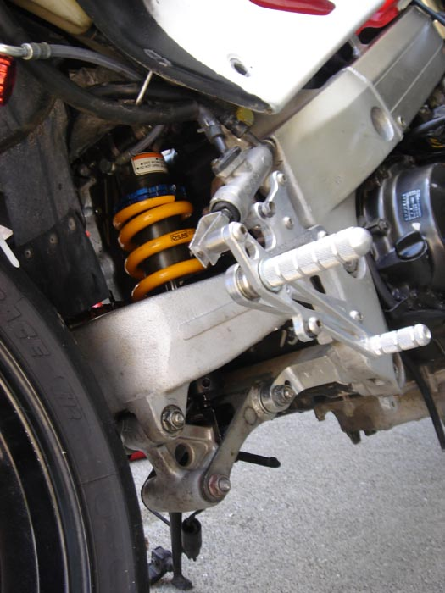
RECHARGE?
Before you recharge, you should test fit the unit on your bike! First release the current charge by depressing the valve located on the remote reservoir (similar to a tire valve) till all the pressure is released. Now crack the lines open just a bit so you can re-adjust them similar to how the original stock shock was mounted with the reservoir (granted your NC30 came with the remote). Do this before you recharge the shock to 180PSI!
DIRECTIONS for adjusting the ride height type shock.
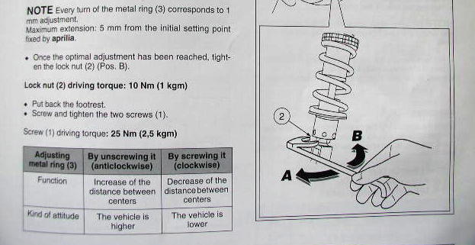
Seems like the optimal height adjustment is 8mm.
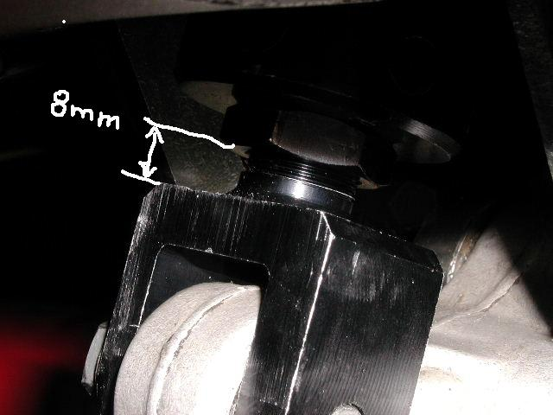
Once completed it will look something like this.
