tart by removing the rear seat unit by removing the 3 screws arrowed below and the same for the other side,
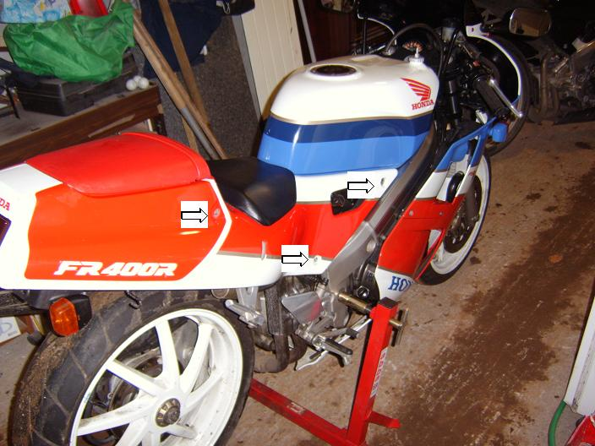
Once you have removed the screws take the pillion seat off and you will see that the seat has 2 plugs at the rear which push into the subframe. Lift the seat from the rear to take the plugs out of these holes. Next remove the brake lights by twisting them anti-clockwise. Once this is done the seat will slide off. You should be left like this,
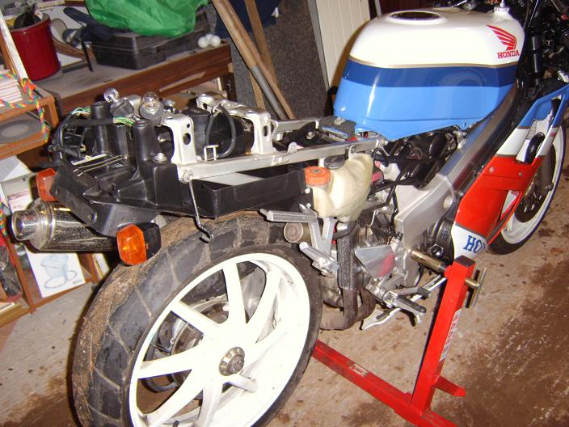
Next you need to remove that tank. The tank is held in with only 1 screw, shown here,
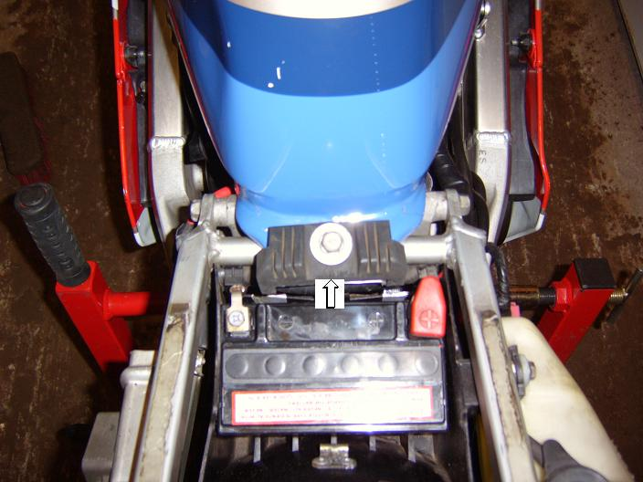
Before you remove the vacuum and fuel line turn off the fuel tap (I’ll take it for granted you know where this is, we’ve all ran onto reserve before). These are next to remove and are found here (sorry about the picture quality). Also remove the breather line too, that goes into the wee silver thing on your tank, take out the tube.
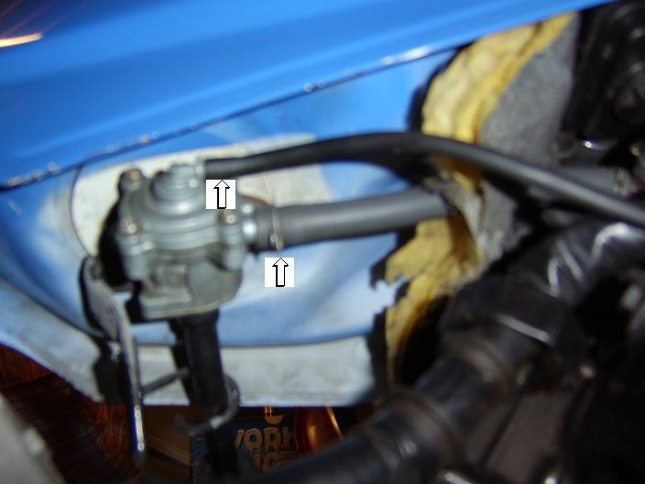
Now remove the tank by lifting it from the rear and slide the front out. Good. Next is 2 more bodywork panels, left side and right. Depending on your fairing type wether original, fibre-glass carbon-fibre etc this may vary so work it out yourself. This is how your bike should now look.
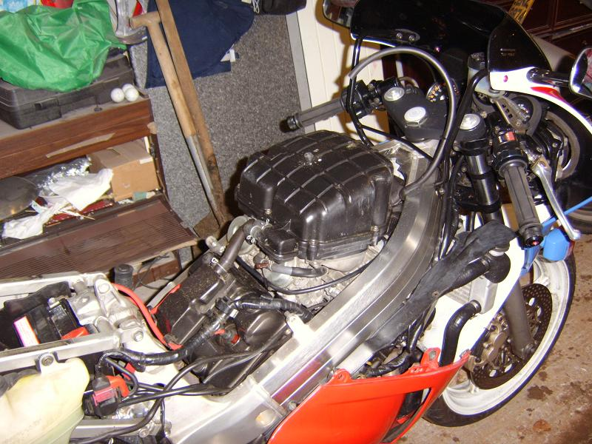
Next up is your air box and filter. There are 3 tubes you need to take off first then 7 screws hold the lid into place. These are the three tubes to remove,
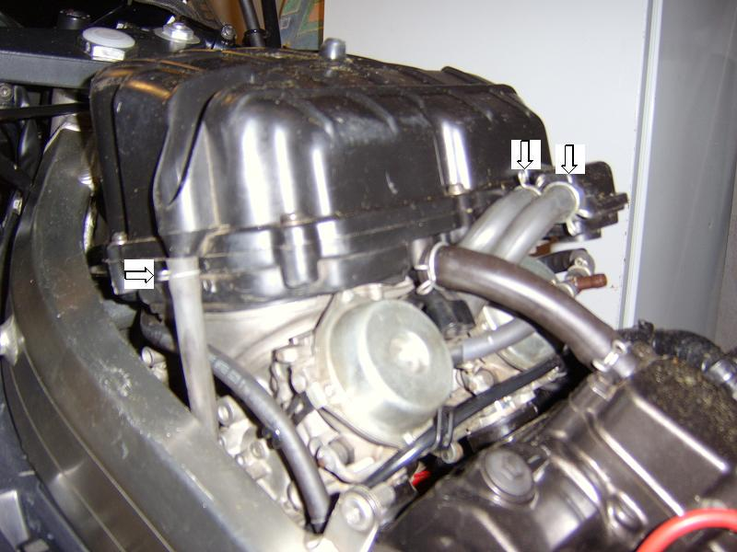
Once off the next thing is to remove the tray which is held in by 4 more screws, also remove the tube going from the airbox tray to the rear cylinder valve cover, that’s the tube you didn’t remove the last time.
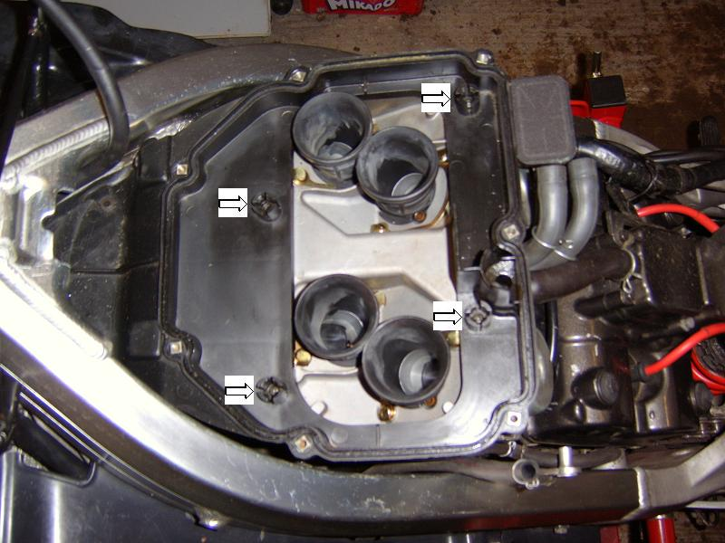
Once out you are now left like the picture below. Good work so far, you nearly have the carbs off. Remove the choke cable by loosening the screw arrowed and also unscrew your idle needle (I forgot about the idle needle before and snapped it, so you have been warned)
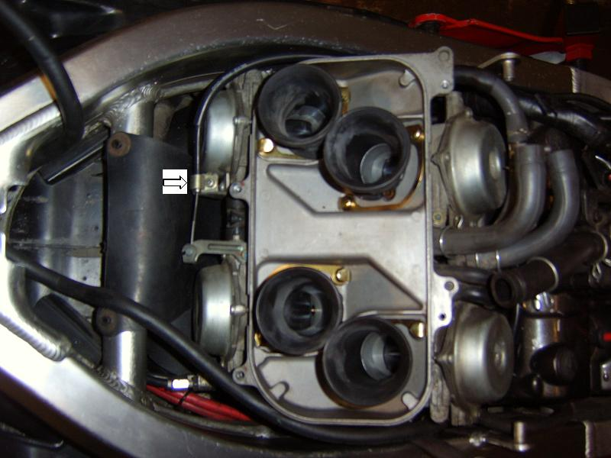
Next up is to loosed the clamps that are on the rubbers which joins the carbs to the engine. Only unscrew the top ones but not right out, keep the nut and bolt together and you don’t need the bottom ones off. The rear ones are easily seen and loosened, the one on the left hand side isn’t too hard either (if you find it hard to do the left hand side unscrew the coil with an 8mm ratchet and socket, this’ll make it easier to get at). If you think the left was hard to get at wait until you see the right hand side. It’s that hard to see I didn’t even try to get a picture, but you will need a flashlight and some patience. The picture below is from the left hand side. Only loosen the one arrowed.
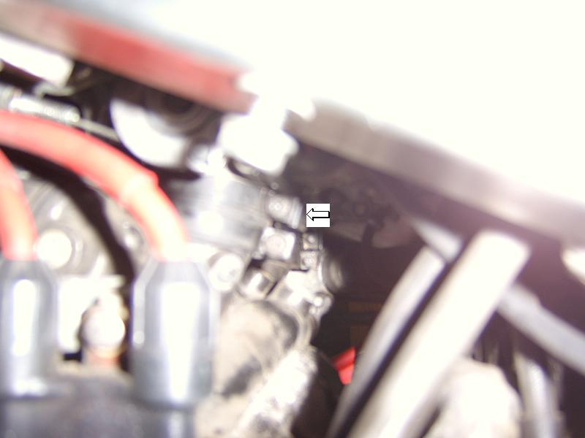
Now that all the clamps are loose (not off) prise the carbs off gently. Once the carbs are out you now need to take off the throttle cables. 2 10mm spanners are needed. Loosen the top one first then take out the nipple from it’s housing, then the bottom one. Once this is done you will now have the carbs in your hands. Congratulations, now have a break.
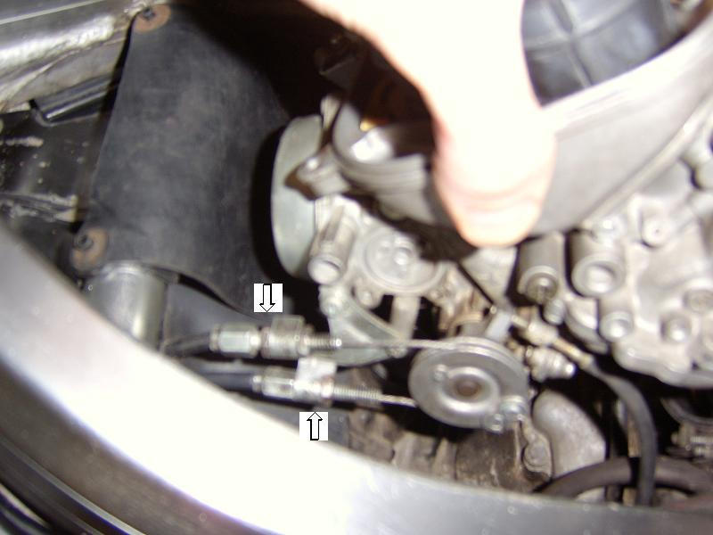
The bike should now look like this, (put a few clothes in each of the holes so as not to get anything in the engine)
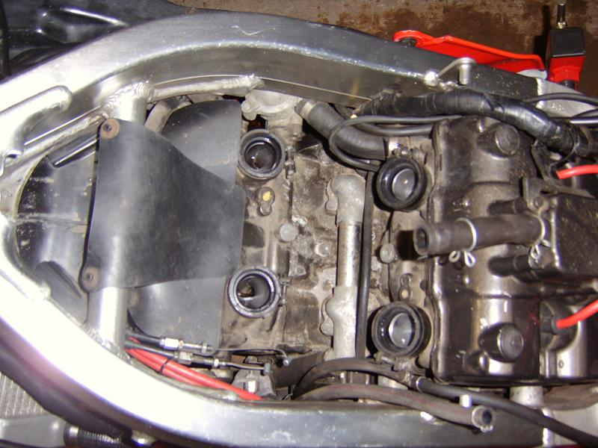
Now that you have the carbs off, don’t turn them upside-down or on their side, there is petrol in there. Next is to get at the needle. Remove the 4 screws holding the cover on and remember, if there are any clips on there put them back the way they should. Place your finger on the cover as you remove the last screw as there’s a spring in there, as shown below,
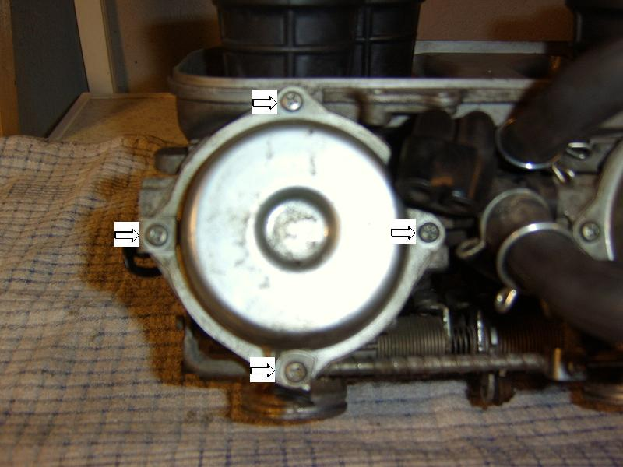
Now that the cover is off, take out the diaphragm, it’ll look like this. (Ignore the arrow, I'll replace this pic with one without it.)
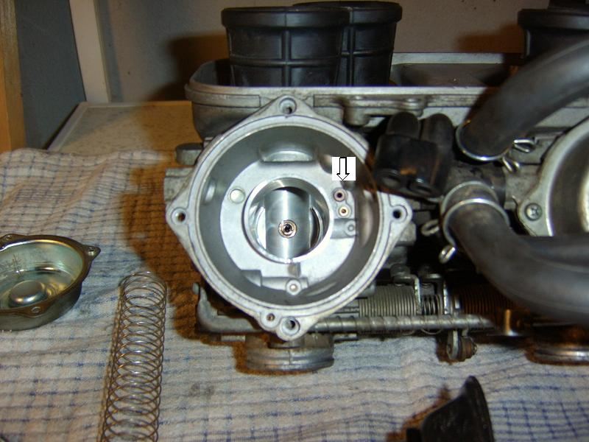
Now that you have the diaphragm and piston assembly in your hand it’s time to take out the needle. Put star head screw-driver in and give it a quarter turn, that’s all that’s needed then push gently up on the needle. Be careful as there is another spring in there and also other small parts, don’t loose any. The following 2 pictures will explain all.
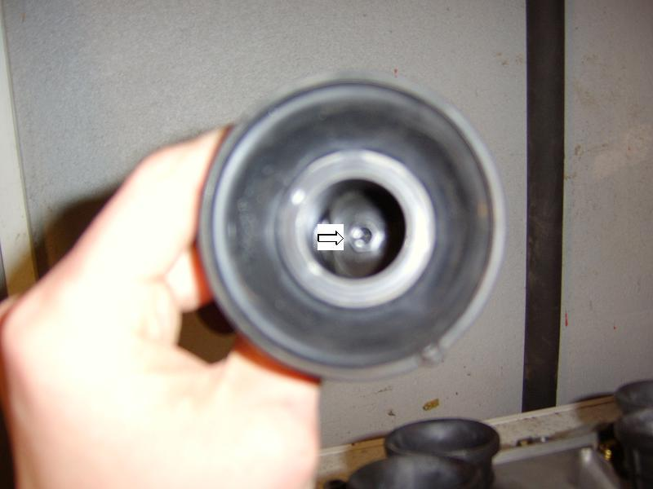
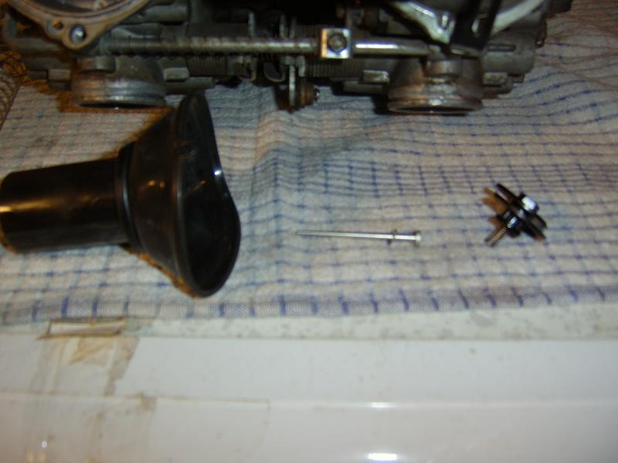
Now that you have the needle out it’s time to drill the slide. Open your nice new drill bit set (see below) and get the 2.5mm bit and drill the hole shown. Be extra careful here with the safety goggles etc.
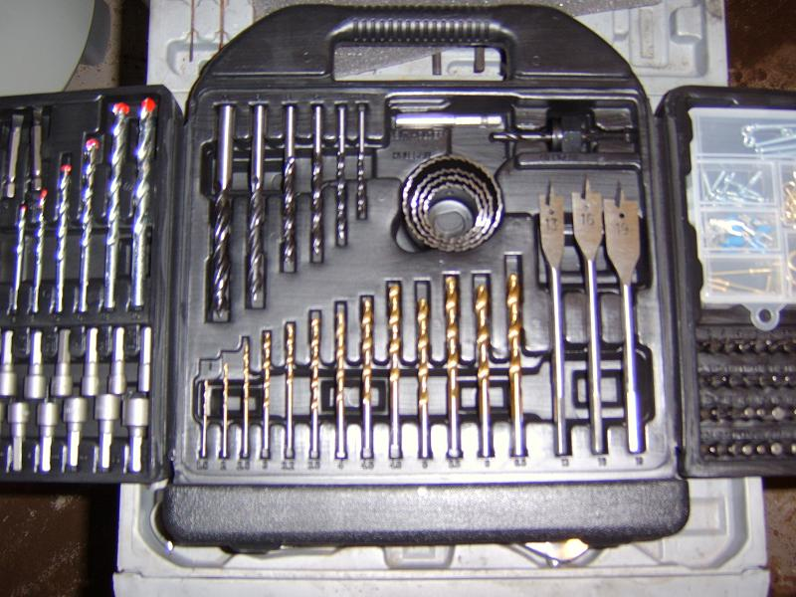
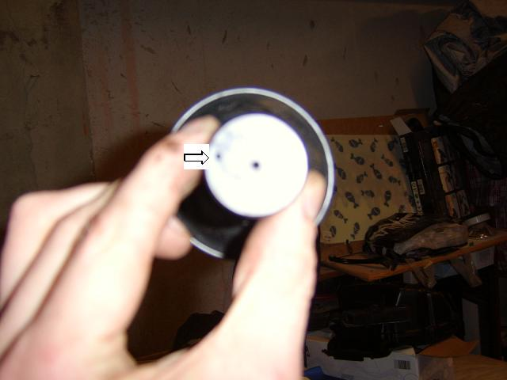
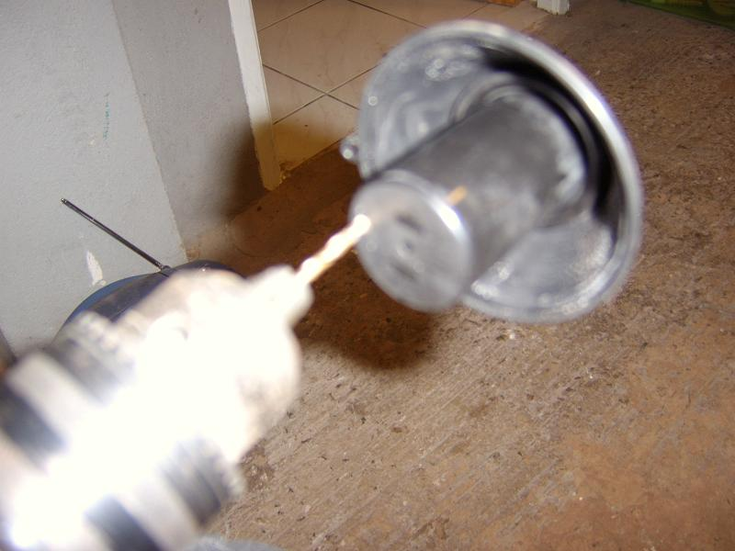
That is the slides now drilled. Next up is fitting the extra 0.5mm washer (or as I did took the old washer out and fitted a 1mm washer instead). Pictured is the needle with the old washer off and the new 1mm to go on.
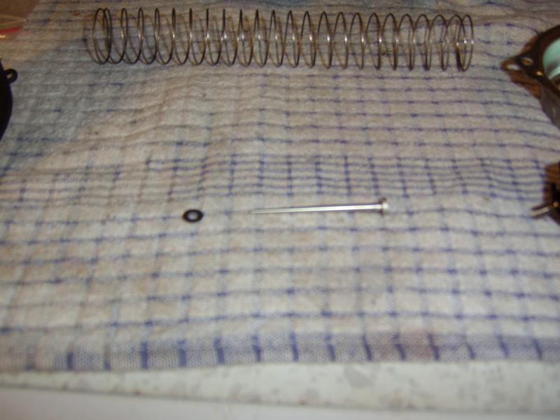
Once the washer is on put the needle back into the assembly followed by the locking mechanism (just the opposite of what you did to take it out) and fit back into the carbs. Correctly align the diaphragm so that it sits where it should. Put the big spring in but don’t forget to give the cover a clean on the inside just for good measure before fitting. Make sure also that the cover is aligned correctly too. Where I have arrowed is how it should look, you must cover the little hole with the cover and mount all the little hangers in their correct place.
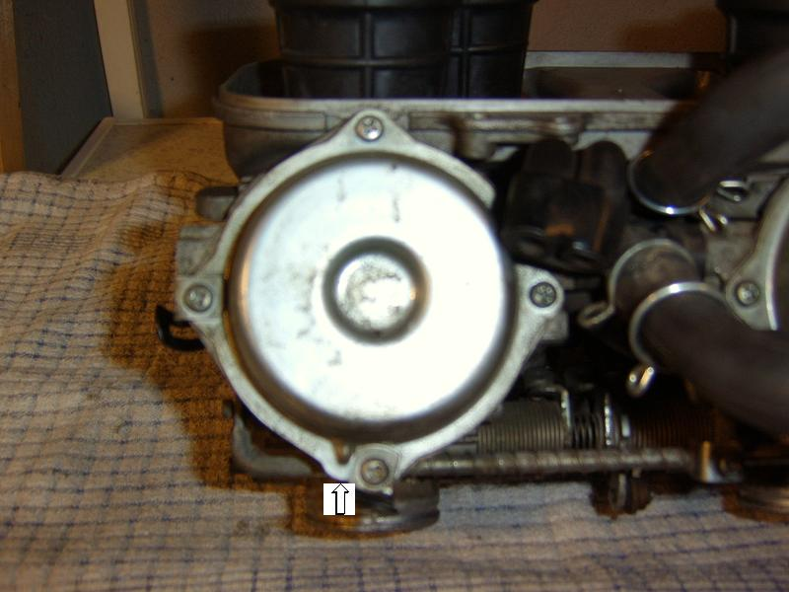
You are now almost finished. Repeat the previous steps 3 more times and the job is almost done. Once fitted with all 4 washers and slides drilled and the carbs back together it’s time to fit the carbs back on again. Pretty much the same as taking them off but can be a bit tricky the first time you do it (if you do it right the first time, well done, cuz I didn’t). Start by making sure the clamps on the rubber seals are loose enough to take the carbs, but not too loose that you push the clamps around every time you touch it with a screwdriver. First you will need to fit the throttle cables, then make sure the choke cable is gonna fit easily (might be a good idea to fit the idle screw too). Once that is done place the front of the carbs into the rubbers on the front head and when slotted in tighten up the clamps (don’t fit the rear yet). Once the clamps are tightened get 2 flathead screwdrivers (2 people would also be good here). Place the screwdrivers on the rubbers (and make sure the heads are clean) so that they act as a shoe-horn and push the rear of the carbs into place. See below.
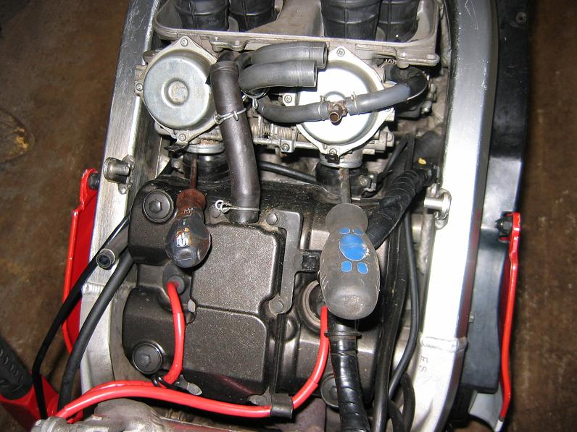
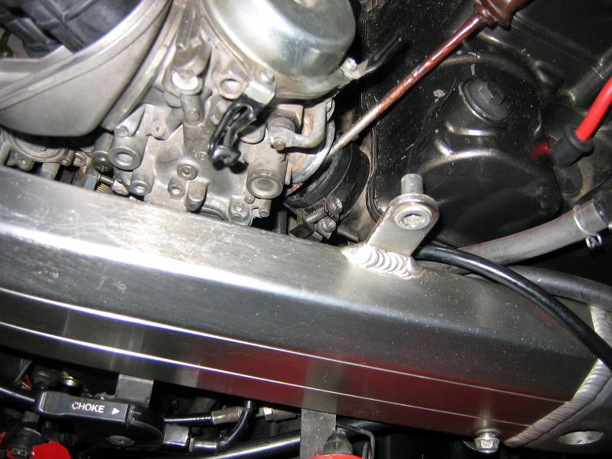
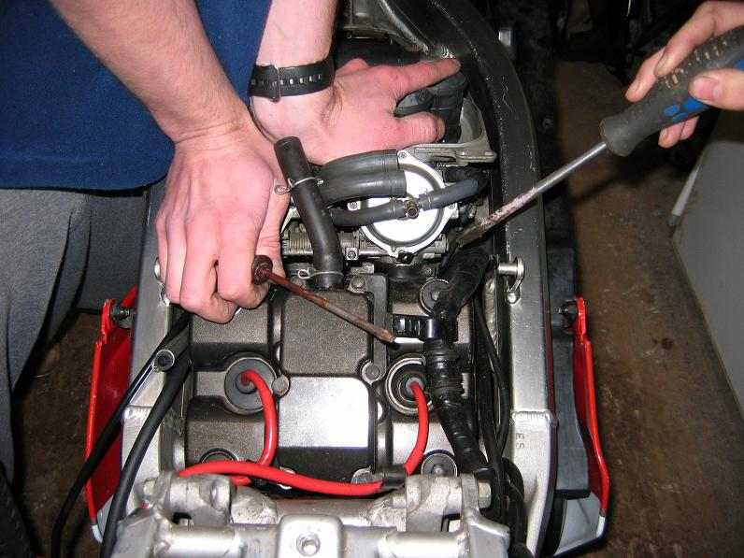
Once the carbs have been fitted at the rear tighten up the last 2 clamps and that’s the hard work done. Now it’s time to fit the air-box, tank, inspection panels, seat and whatever else you took off. Once this is done take yourself out of the garage about stretch the bikes legs, and don’t forget to enjoy yourself and keep it ‘Black on Black’.

